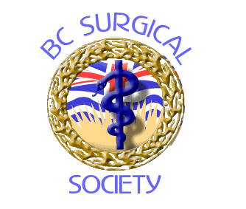BC Surgical Society

73rd Annual Spring Meeting: May 7 – 9, 2020
Delta Victoria Ocean Pointe Resort, BC

ABSTRACT FORM [Videos]

Instructions to Authors – Video Session

- The Video should be submitted by a member of the BCSS or candidate (resident) group.
- The content can be anything deemed of educational benefit to BCSS members.
- The Video must be in a standard digital format (avi, mov, wma, etc).
- There will be 5-7 minutes allotted for the video and 5 minutes for discussion.
- Permission to publish this abstract should be given by the senior author.

Please include the following information in the box below:
• Title • Authors [mark presenter with *] • Summary

This summary sheet must be submitted by the deadline or will not be considered.
The video file must be submitted by April 23rd. 2020. Videos exceeding 7 minutes duration will not be accepted.

Deadline: Monday, January 6th 2020

*Papers presented at the Annual Spring Meeting may be published on the BC Surgical Society website for viewing purposes only.

Presenter: | Click to enter text. | Submit to: | Alyson Thomas  BCSS Coordinator  admin@bcss.ca
Institution: | Click to enter text.
Email: | Click to enter text.

